MIT Assignment-02

Jeetu Mehra
U24AI032

Question 1 : Write instruction to load the two hexadecimal numbers 32H and 48H in registers A and B, respectively. Add the numbers, and display the sum at the output port 02.
Output:
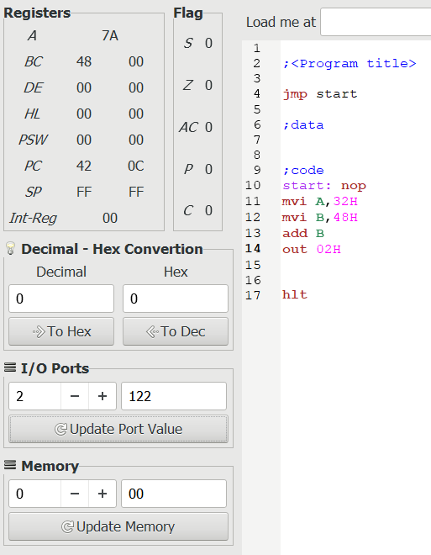
Question 2: Write instruction to load an 8-bit number in a B.
Output:
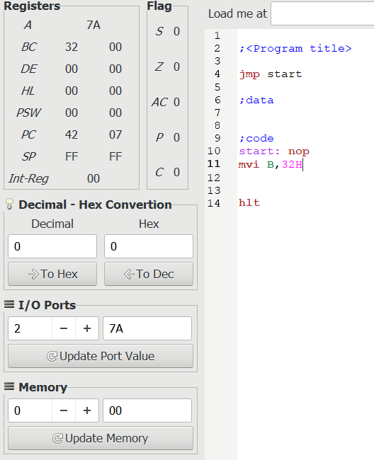

Question 3: Write instruction to load a 16-bit number in a BC register pair.
Output:

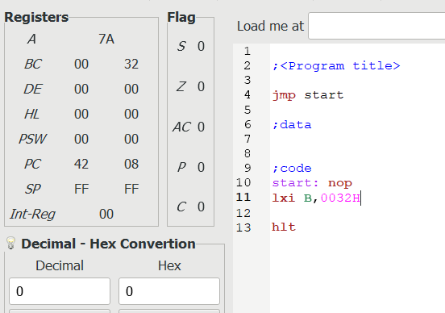

Question 4 : Write instruction to copy data from register B to register H.
Output:
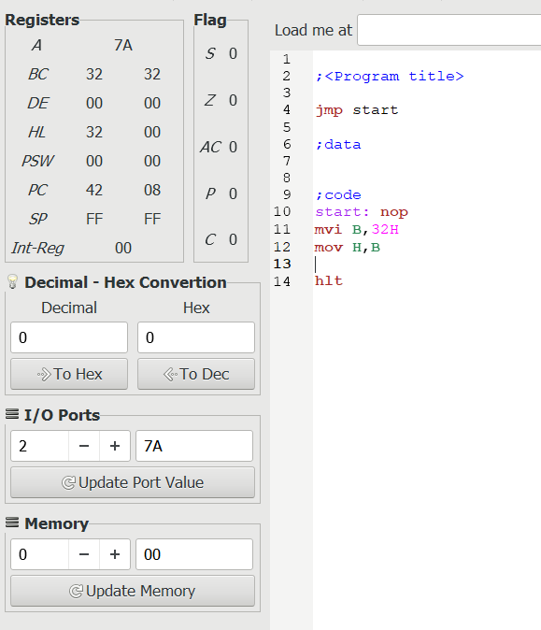

Question 5 : Write instruction to copy data from register B to memory location 0008H.
Output:
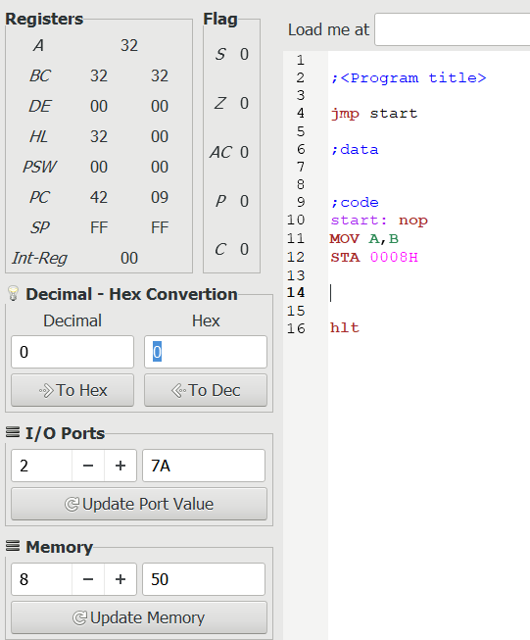

Question 6 : Write instruction to transfer data of accumulator to memory location 0002H
Output:
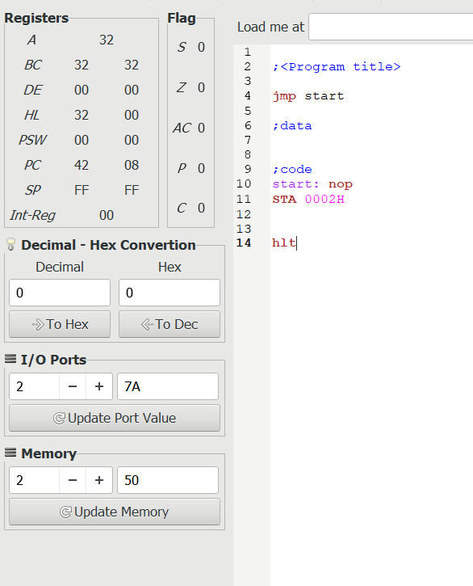

Question 7 : Write instruction to accept data from port 08H and place it in accumulator.(IN)
Output:
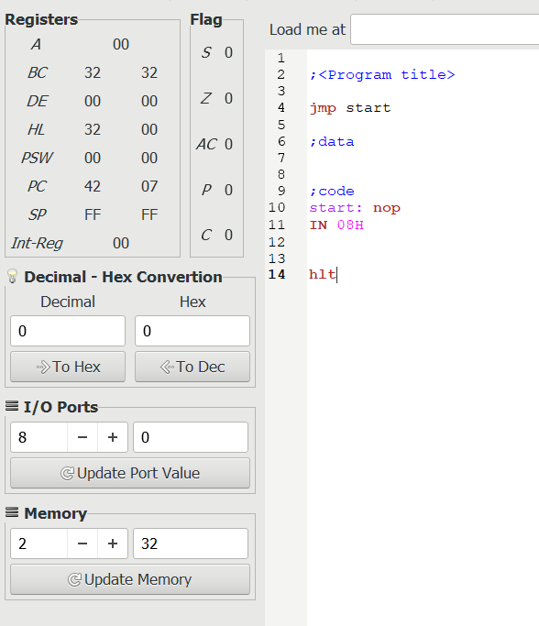

Question 8 : Write instruction to accept data from memory location 003F and place it in accumulator.(LDA)
Output:
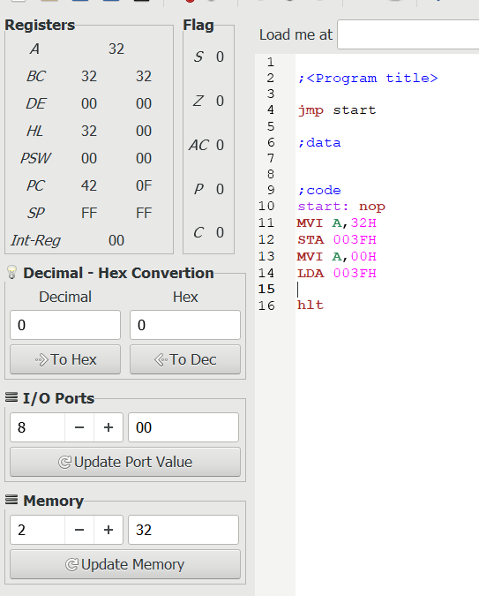

Question 9 : Write instruction to copy data (results)from accumulator to memory location 0008H.(STA)
Output:
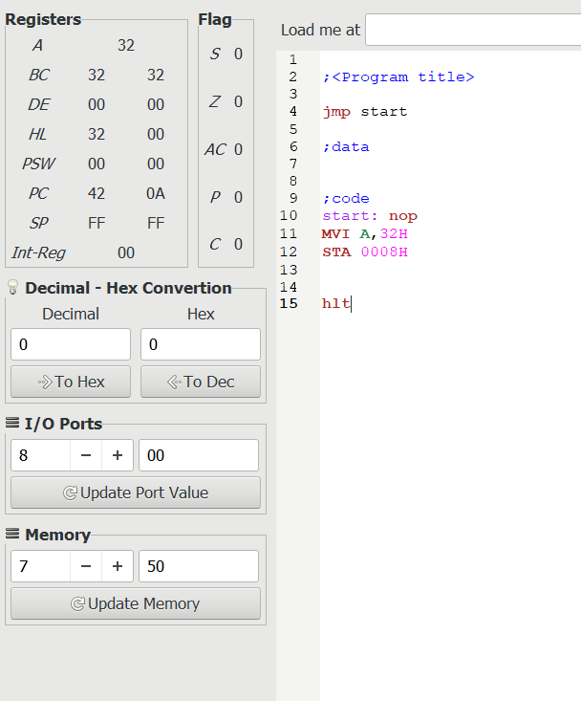

Question 10 : A. load data 05H to memory location 003E H.
B. Store this memory location to register C.
C. Copy the data of memory location stored in C to accumulator.
Output:
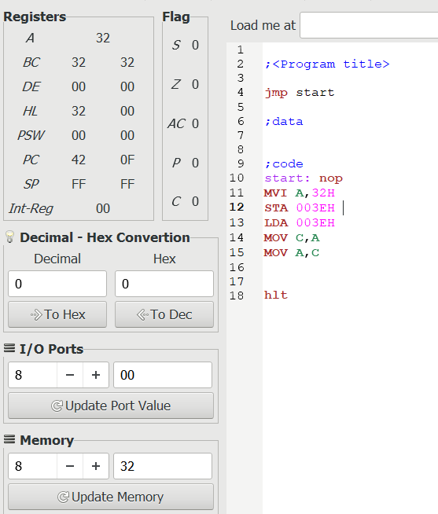

Question 11: Copy the data of accumulator into the memory specified by the address in register pair BC.
Output:
